**Worksheet 2: Highway Hazards**

While cruising along a dark stretch of highway with the cruise control set at 25 m/s (≈55 mph), you see, at the fringes of your headlights, that a bridge has been washed out. You apply the brakes and come to a stop in 4.0s. *Assume the clock starts the instant you hit the brakes.*

1. Construct a motion map that represents the motion described above, including position, velocity, and acceleration. Clearly demonstrate how you can determine the direction (sign) of the acceleration from the motion map representation.

2. Construct **qualitative** graphical representations of the situation described above to illustrate:

a. **x** vs. **t**

b. **v** vs. **t**

c. **a** vs. **t**

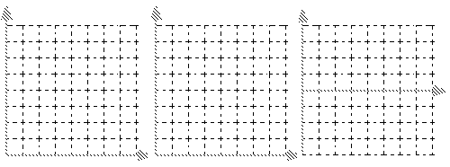

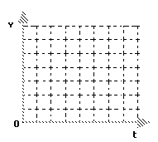3. Construct a **quantitatively accurate** **v** vs **t** graph to describe the situation.

4. On the **v** vs **t** graph at right, graphically represent the car’s displacement during braking.

5. Utilizing the **graphical representation**, determine how far the car traveled during braking. (Please explain your problem solving method.)

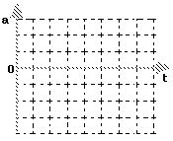

6. In order to draw the **a** vs **t** graph, you need to determine the car’s acceleration. Please do this, then sketch a **quantitatively accurate** **a** vs **t** graph

**Computer simulation:**

A blue car is travelling down a road when the driver notices a fallen tree across the street.

Your goal is to write functions which will:

* Compute the next position.
* Compute the next velocity.
* Test for a collision.
* Test for braking.

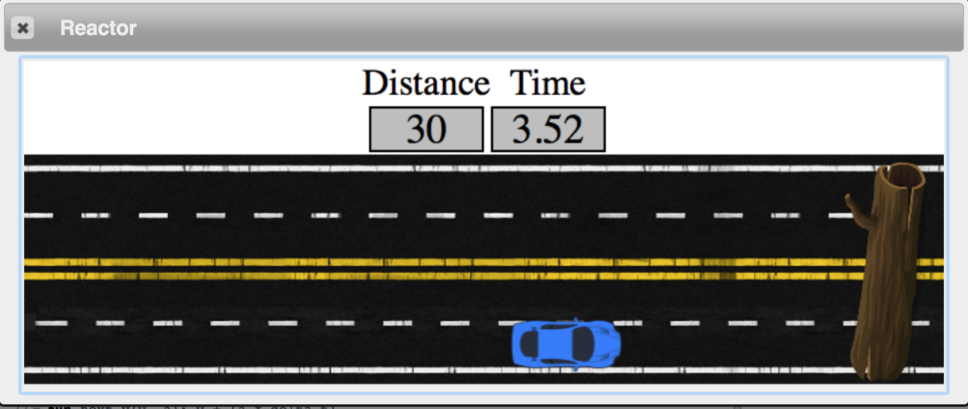

Construct a motion map of your intended motion:

Construct a qualitatively accurate v vs t graph. 